Phrase Forms
- Infinitive Verb Phrases
  - To + Base Verb
    - To run, to jump, to think, to explain…
  - Can be used as…
    - Adverbial: I added some extra salt to balance the sweetness.
    - Nominal (subject): “To know you is an absolute pleasure.”
    - Nominal (object): I will try to keep up.

- Present Participle Verb Phrases
  - Verb + ing
    - Swimming, climbing, objecting, being…
  - Can be used as…
    - Main Verb in progressive aspect: She is succeeding!
    - Auxiliary Verb in progressive passive voice: “The lawn is being mowed.
    - Adverbial: Regarding your essay, it was excellent.
    - Adjectival: The guy mowing the yard makes more than I do.
    - Nomina (subject): Mowing the yard can cause my allergies to flare up.
    - Nominal (object): I always dread mowing the yard.
- Past Participle Verb Phrases
  - Regular = Verb + ed
    - Walked, Clapped, Complained, Combined….
  - Many irregular forms
    - Gone, spent, run, given…
    - It’s the one that follows “had” – had given, had swum, had thought….
  - Can be used as…
    - Main Verb in Perfect Aspect: “It I have spent all my money.
    - Main Verb in Passive Voice: All my money has been spent (by me).
    - Adjectival (pre-headword): Many of the predicted changes are actually positive.
    - Adjectival (post-headword). Many of the changes predicted by the UN are actually positive.

Embedded Clause Forms
- Relative Clause
  - A whole clause embedded in a sentence – acting as an Adjectival (modifying a noun)
    - Starts with a “Relativizer”
      - That, which, where, when, who, whom, whose
    - Relativizer can precede the subject of the Relative Clause
      - The candles that mom likes are on sale.
    - Relativizer can BE the subject of the Relative Clause
      - The candles that smell good are on sale.
  - Can ONLY be used as a post-headword adjectival!
    - Adjectival (post-headword – headword is subject): The book that I read last month was way too long.
    - Adjectival (post-headword – headword is object): I almost didn’t buy the book that I read last month.
    - Adjectival (post-headword – headword is complement): Oh, this is the book that I read last month!

- Complement Clause (also called “Nominal Clause”)
  - A whole clause embedded in a sentence – acting as a Nominal (Subject, Object, or Complement)
    - Starts with a “Complementizer”
      - That, how, where, when, who, whom, whose
    - Complementizer can precede the subject of the Complement Clause
      - I think that you hid my money!
    - Complementizer can BE the subject of the Relative Clause
      - I know who hid my money.
  - Can only be used in place of a noun!
    - Complement Clause as Direct Object: I explained how a car works.
    - Complement Clause as Complement: The best idea was that we add a ten-minute lunch break.
    - Complement Clause as Subject: When tornados will strike cannot be predicted.

Functions
- Adverbials – Acting as an Adverb
  - Noun Phrases serving as Adverbials
    - Tomorrow, I will attend a basketball game.
    - I will finish my novel someday.
  - Present Participle Verb Phrases as Adverbials
    - Complicating matters further, Sarah was a werewolf!
    - Johnny spit on another kid, really trying his teacher’s patience.
  - Infinitive Verb Phrases as Adverbials
    - Stumped by the question, Patrick took a moment to consider his response.

- Adjectivals – Acting as an Adjective
  - Present Participle Verb phrases serving as Adjectivals
    - The man running the race collapsed from exhaustion.
    - The simpering fool dropped to the floor.
  - Past Participle Verb Phrases serving as Adjectivals
    - The bill ratified by the states gave women the right to vote.
    - The recently discovered temple may hod many secrets.
  - Relative Clauses
    - The time when papers are due is rapidly approaching.
    - I enjoy basketball players whose defense is good.

- Nominals – Acting as a Noun
  - Present Participle Verb Phrases serving as Nominals (also called “Gerunds”)
    - I propose selling the car for scrap.
    - Believing in magic is not just for children.
  - Infinitive Verb Phrases serving as Nominals
    - I try to be kind.
    - To know him is to love him.
  - Complement Clauses
    - I explained how a magnet works.
    - Who is at fault remains a matter of debate.

- Noun Phrases as Adverbials
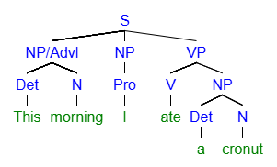
ROLE | Adverbial |  | Subj | Pred | Direct Object (DO)
PHRASE | NP |  | NP | VP | NP
WORD | This | Morning | I | Ate | A | Cronut
Part of Speech | Det | N | Pro | V | Det | N

[S [NP/Advl [Det This] [N morning]] [NP [Pro I]] [VP [V ate] [NP [Det a] [N cronut]

- Present Participle Verb Phrases as Adverbials
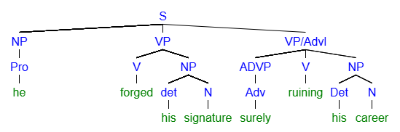

ROLE | Subj | Pred | DO |  | Adverbial
PHRASE | NP | MVP | NP |  | VP
WORD | He | Forged | His | Signature | Surely | Ruining | His | Career
Part of Speech | Pro | V | Det | N | Adv | V | Det | N

[S [NP [Pro he]] [VP [V forged] [NP [det his] [N signature]]] [VP/Advl [ADVP [Adv surely]] [V ruining] [NP [Det his] [N career]
- Infinitive Verb Phrases as Adverbials
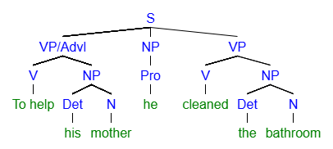
ROLE | Adverbial |  |  | Subj | Pred | DO
PHRASE | VP |  |  | NP | MVP | NP
WORD | To Help | His | Mother | He | Cleaned | The | Bathroom
Part of Speech | V | Det | N | Pro | V | Det | N

[S [VP/Advl [V To help] [NP [Det his] [N mother]]] [NP [Pro he]] [VP [V cleaned] [NP [Det the] [N bathroom]
- Present Participle Verb Phrases as Adjectivals
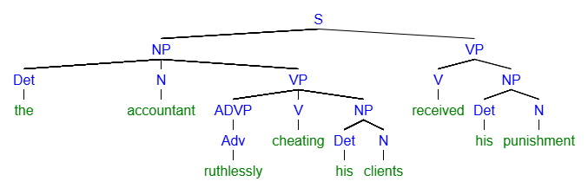
ROLE | Subj |  | Adjectival |  |  |  | Pred | DO
PHRASE | NP |  | VP |  |  |  | VP | NP
WORD | The | Accountant | Ruthlessly | Cheating | His | Clients | Received | His | Punishment
Part of Speech | Det | N | ADVP | V | Det | N | V | Det | N

[S [NP [Det the] [N accountant] [VP [ADVP [Adv ruthlessly]] [V cheating] [NP [Det his] [N clients]]]] [VP [V received] [NP [Det his] [N punishment]
- Past Participle Verb Phrases as Adjectivals
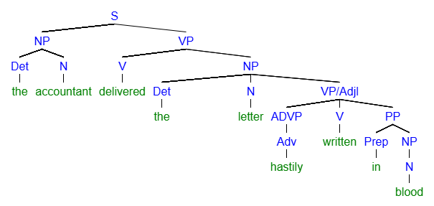
ROLE | Subj |  | Pred | DO |  | Adjectival
PHRASE | NP |  | VP | NP |  | VP
WORD | The | Accountant | Delivered | The | Letter | Hastily | Written | In | Blood
Part of Speech | Det | N | V | Det | N | Adv | V | Prep | N

[S [NP [Det the] [N accountant]] [VP [V delivered] [NP [Det the] [N letter] [VP/Adjl [ADVP [Adv hastily]] [V written] [PP [Prep in] [NP [N blood]

- Infinitive Phrases as Nominals (Direct Object)
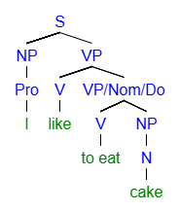
ROLE | Subj | Pred | DO
PHRASE | NP | VP | VP
WORD | I | Like | To Eat | Cake
Part of Speech | Pro | V | V | N

- Present Participle Verb Phrases as Nominals (Subject) – also called “Gerunds”
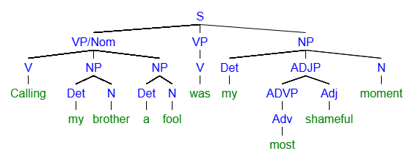
ROLE | Subj |  |  |  |  | Pred | Subj Complement
PHRASE | VP |  |  |  |  | MVP | NP
WORD | Calling | My | Brother | A | Fool | Was | My | Most | Shameful | Moment
Part of Speech | V | Det | N | Det | N | V | Det | Adv | Adj | N

[S [VP/Nom [V Calling] [NP [Det my] [N brother]] [NP [Det a] [N fool]]] [VP [V was]] [NP [Det my] [ADJP [ADVP [Adv most]] [Adj shameful]] [N moment]

- Relative Clause – Relativizer as Subject
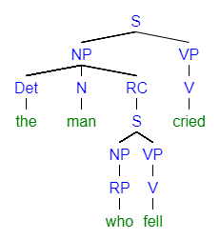
CLAUSE | Main |  | Relative |  | Main
ROLE | Subj |  | Adjectival |  | Pred
PHRASE | NP |  | NP | VP | VP
WORD | The | Man | Who | Fell | Cried
Part of Speech | Det | N | REL | V | V

- Relative Clauses – Relativizer Preceding Subject
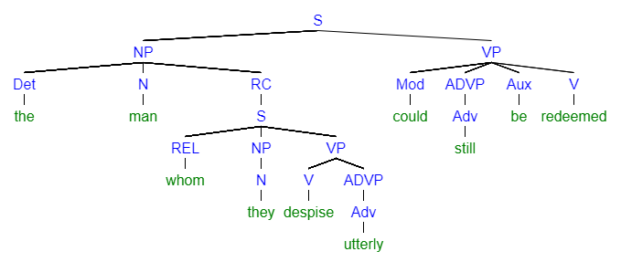
CLAUSE | Main |  | RC |  |  |  | Main
ROLE | Subj |  | Adjectival |  |  |  | Pred
PHRASE | NP |  | --- | NP | VP |  | VP
WORD | The | Man | Whom | They | Despise | Utterly | Could | Still | Be | Redeemed
Part of Speech | Det | N | Rel | Pro | V | Adv | Mod | Adv | Aux | V

- Relative Clause modifying a Direct Object
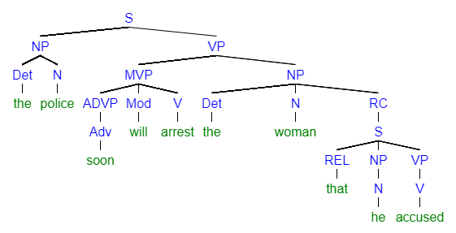
CLAUSE | Main |  |  |  |  |  |  | RC
ROLE | Subj |  | Pred |  |  | DO |  | Adjectival
PHRASE | NP |  | VP |  |  | NP |  | --- | NP | VP
WORD | The | Police | Will | Soon | Arrest | The | Woman | That | He | Accused
Part of Speech | Det | N | Mod | Adv | V | Det | N | Rel | Pro | V

[S [NP [Det the] [N police]] [VP [MVP [ADVP [Adv soon]] [Mod will] [V arrest]] [NP [Det the] [N woman] [RC [S [REL that] [NP [N he]] [VP [V accused]

- Complement/Nominal Clause - Complementizer as Subject
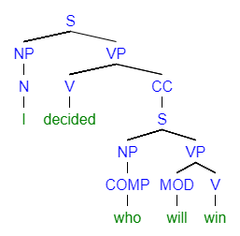
CLAUSE | Main |  | Complement Clause
ROLE | Subj | Pred | Direct Object
PHRASE | NP | VP | NP | VP
WORD | I | Decided | Who | Will | Win
Part of Speech | Pro | V | Comp | Mod | V

- Complement/Nominal Clause - Complementizer as Preceding Subject
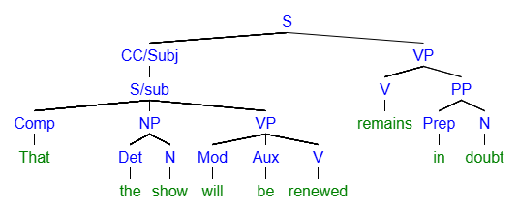

CLAUSE | Complement Clause (CC) |  |  |  |  |  | Main
ROLE | Subj |  |  |  |  |  | Pred | Subj Comp
PHRASE | --- | NP |  | VP |  |  | VP | PP
WORD | That | The | Show | Will | Be | Renewed | Remains | In | Doubt
Part of Speech | Comp | Det | N | Mod | Aux | V | V | Prep | N

[S [CC/Subj [S/sub [Comp That] [NP [Det the] [N show]] [VP [Mod will] [Aux be] [V renewed]]]] [VP [V remains] [PP [Prep in] [N doubt]
- Complement/Nominal Clause – Complementizer Preceeding Subject
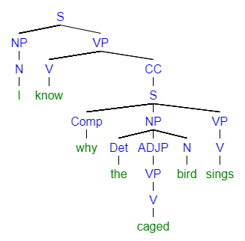
CLAUSE | Main |  | Complement Clause
ROLE | Subj | Pred | Direct Object
PHRASE | NP | VP | --- | NP |  |  | VP
WORD | I | Know | Why | The | Caged | Bird | Sings
Part of Speech | Pro | V | Comp | Det | V | N | V

